# This article is about the OT-One.

## **It's no-longer sold or actively supported by Opentrons, but we've kept this article here to help existing users. Please** [**see our OT-2 Support articles**](https://support.opentrons.com/) **for the most up to date information!**

You will need a computer running the Opentrons App in order to control your OT-One robot. Our app runs on Windows 10 64-bit operating systems and on most versions of Mac OS. You can download the appropriate app by clicking the “Mac” or “Windows” buttons underneath the image below!

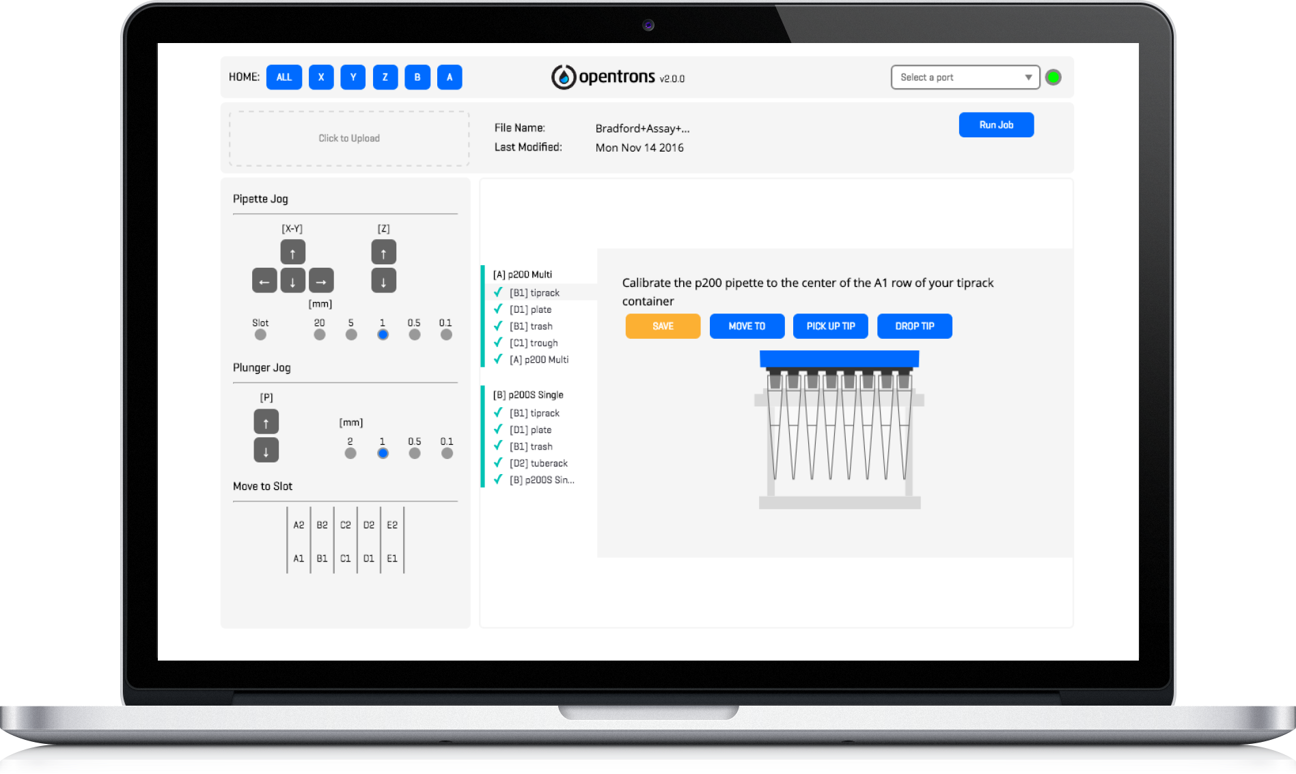

[**Mac**](https://ot-app-releases-2.herokuapp.com/latest?platform=darwin)

[**Windows**](https://s3.amazonaws.com/ot-app-builds/win/opentrons-v2.5.2-win-2017-08-18_21-09-release-2.5.2-bedf147.exe)

[**Linux**](https://s3.amazonaws.com/ot-app-builds/linux/opentrons-v2.5.2-linux-amd64-2017-08-18_22-17-release-2.5.2-4e7393c.deb)